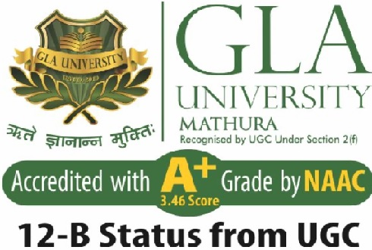
Department of Computer Engineering and Applications

GLA University, 17 km Stone, NH#2, Mathura-Delhi Road, P.O. Chaumuhan, Mathura-281406 (U.P.)

Declaration

I hereby declare that the work which is being presented in the B.Tech. Project “Text-to-image Generation”, in partial fulfillment of the requirements for the award of the Bachelor of Technology in Computer Science and Engineering and submitted to the Department of Computer Engineering and Applications of GLA University, Mathura, is an authentic record of my own work carried under the supervision of Name & Designation of Supervisor(s).
The contents of this project report, in full or in parts, have not been submitted to any other Institute or University for the award of any degree.

Sign ______________________ Sign ______________________
Name of Student : Shray Gupta Name of Student : Yash Patel
University Roll No.: 2115000 University Roll No.: 2115001156

Certificate

This is to certify that the above statements made by the candidate are correct to the best of my/our knowledge and belief.

_______________________

Supervisor
(Name of Supervisor)
Designation of Supervisor
Dept. of Computer Engg, & App.

______________________ ______________________

Project Co-ordinator Program Co-ordinator
(Dr. Mayank Srivastava) (Dr. Nikhil Govil)
Associate Professor Associate Professor
Dept. of Computer Engg, & App. Dept. of Computer Engg, & App.

Date:

